Capstone Project Outline
📑 Capstone Project Outline
Title: The Economic Impact of Communication Technology on Growth and Society in the USA

I. Introduction
- Brief history of communication evolution: from letters → telegraph → telephone → mobile → internet → social media → remote tools.
- Purpose: Explore how communication technologies contribute to GDP, productivity, inequality, and business transformation.
- Research Questions (the six you listed).

II. Literature Review
- Diffusion of Innovations (Everett Rogers): How technologies spread and reshape economies.
- Prior research linking communication to GDP growth and productivity.
- Studies on digital vs. traditional communication costs.
- Economic analysis of advertising shifts (TV → social media).
- Research on digital divides and inequality.

III. Methodology
- Data Sources:
  - World Bank (GDP, ICT penetration)
  - ITU (telecom/mobile/internet subscriptions)
  - OECD (digital economy and productivity reports)
  - BLS / Eurostat (remote work productivity data)
  - Statista / eMarketer (digital ad spend trends)
- Analysis Methods:
  - Time-series (GDP vs. ICT adoption rates).
  - Cost-benefit analysis (mail vs. digital comms).
  - Regression/correlation (remote work adoption vs. productivity).
  - Comparative analysis (traditional vs. digital ad ROI).
  - Cross-country inequality comparisons.

Outline Condensed:
• Introduction: Overview of communication’s evolution in the U.S. over the past 50 years — from letters and landlines to the internet, social media, and remote work tools — and its economic influence.
• Purpose & Scope: Examine how communication technologies have shaped GDP growth, productivity, inequality, and business transformation in the U.S.
• Research Questions: Focus on six key areas, including GDP contribution, cost-benefit of digital vs. traditional communication, remote work productivity, advertising shifts, inequality, and future trends.
• Literature Context: Build on theories of innovation diffusion and prior research connecting communication technology with economic growth, digital transformation, and equity.
• Data & Methods: Use U.S. and global datasets (BEA, World Bank, BLS, ITU, OECD) with time-series, regression, and cost-benefit analyses to explore patterns and relationships.
• Deliverable: A 15-minute presentation using Google Slides, supported by clear visuals and data storytelling to illustrate communication’s economic impact.

IV. Data Analysis & Findings
1. Global GDP Growth & Communication Tech
- Dataset: World Bank GDP + ITU ICT adoption.
- Approach: Plot GDP growth alongside adoption of phones, internet, and broadband.
2. Cost-Benefit: Digital vs. Mail/Landlines
- Dataset: U.S. Postal Service revenue vs. internet/email growth.
- Approach: Compare communication cost per message/mail vs. email/text.
3. Remote Work & Productivity
- Dataset: BLS, OECD remote work statistics.
- Approach: Compare productivity growth pre- and post-remote work adoption (esp. pandemic era).
4. Social Media vs. Traditional Advertising Value
- Dataset: Statista/eMarketer ad spend by channel.
- Approach: Compare ROI metrics of digital vs. TV/print.
5. Communication & Inequality
- Dataset: GSMA mobile penetration, World Bank ICT access, income inequality indexes (Gini coefficient).
- Approach: Regression of communication accessibility vs. income inequality.
6. Future Trends (5–10 Years)
- Sources: Gartner, McKinsey, WEF reports.
- Focus: AI-driven communication, AR/VR meetings, 6G networks, digital financial inclusion.

V. Discussion
- Connect findings back to each research question.
- Highlight both positive economic impacts and unintended consequences.
- Cross-generational and global insights.

VI. Conclusion & Recommendations
- Summary of communication as an economic growth driver.
- Recommendations for policymakers (e.g., expanding broadband to reduce inequality).
- Forecast: The role of AI and immersive communication in future economies.

How To Get Started
📑 Capstone Project Outline
Title: The Economic Impact of Communication Technology on Global Growth and Society

I. Introduction
- Context & Background
  - Brief history of communication evolution (letters → telegraph → telephone → mobile → internet → social media → remote platforms).
- Problem Statement
  - While communication technologies have transformed global economies, their economic effects on GDP, productivity, inequality, and industries require deeper analysis.
- Purpose & Significance
  - Explore the financial and economic impacts of communication technology, linking adoption to measurable outcomes.
- Research Questions (from your list)
  - How has the evolution of communication technology contributed to US GDP growth?
  - What is the economic cost-benefit of digital communication vs. traditional mail/landlines?
  - How has remote work communication technology reshaped labor productivity?
  - What is the financial value of social media as a communication channel compared to traditional advertising?
  - How does communication accessibility impact income inequality across countries?
  - How has the evolution of communication technology affected mental health, and what are the economic implications?
  - Where is this trend going in the next 5–10 years?

II. Literature Review
- Historical Foundations
  - Economic impact of earlier communication technologies (telegraph, telephone, radio, TV).
- Global GDP & ICT
  - Studies linking ICT (Information & Communication Technology) adoption to GDP growth.
- Cost-Benefit Analyses
  - Research on digital vs. traditional mail/landline costs.
- Labor Productivity & Remote Work
  - Pandemic-era studies and longer-term workplace productivity data.
- Advertising Transformation
  - Shift of ad spend from traditional to digital/social channels.
- Digital Divide & Inequality
  - Literature on communication access gaps between nations and income groups.
- Future Trends
  - Forecasts on AI, AR/VR, and communication-driven economies.

III. Methodology
- Approach: Quantitative data analysis + qualitative insights.
- Data Sources:
  - World Bank (GDP, ICT adoption)
  - ITU (internet, mobile subscriptions)
  - OECD & BLS (productivity, remote work data)
  - GSMA (mobile economy reports)
  - Statista/eMarketer (advertising spend)
- Analysis Methods:
  - Time-series analysis (ICT adoption vs. GDP growth).
  - Cost-benefit calculations (mail vs. email/text).
  - Correlation/regression (remote work adoption vs. productivity).
  - Comparative ROI analysis (social media vs. traditional ads).
  - Inequality analysis (ICT penetration vs. Gini index).

IV. Data Analysis & Results
- RQ1 – GDP Growth:
Charts showing GDP growth relative to ICT adoption worldwide.
- RQ2 – Cost-Benefit:
Comparison of per-message/mail costs vs. digital alternatives.
- RQ3 – Productivity:
Pre/post remote work productivity graphs.
- RQ4 – Advertising Value:
Ad spend and ROI shifts between TV, print, and digital/social.
- RQ5 – Inequality:
Cross-country analysis of communication accessibility vs. income inequality.
- RQ6 – Future Trends:
Scenario forecasting (5–10 years) based on Gartner, WEF, McKinsey reports.

V. Discussion
- Interpret results for each research question.
- Address whether communication technologies act as economic growth drivers or as potential amplifiers of inequality.
- Highlight both positive and negative financial outcomes.

VI. Conclusion
- Restate findings in relation to research questions.
- Discuss overall economic significance of communication technology evolution.
- Provide policy and business recommendations, such as:
  - Expand digital infrastructure to reduce inequality.
  - Leverage remote work tools for long-term productivity gains.
  - Adapt to digital-first advertising strategies.
- Reflect on limitations of the study (data gaps, scope).
- Suggest areas for future research (AI-driven comms, AR/VR economics).

VII. References
- Use APA/MLA citation style depending on requirements.
- Sources: academic journals, government datasets, industry reports (World Bank, ITU, OECD, APA, WEF).

VIII. Appendices (if required)
- Additional charts, tables, or raw data visualizations.
- Survey questions if you add a qualitative component.

✅ This structure ensures your capstone has a clear narrative (intro → lit review → methodology → findings → conclusion) while staying focused on data-driven economic analysis.

Research Leads
Research Leads (Direct Sources)
- World Bank Data – ICT & GDP
  - World Bank Data
- International Telecommunication Union (ITU)
  - ITU Statistics
- OECD Digital Economy Outlook
  - OECD Reports
- Bureau of Labor Statistics (Remote Work Data)
  - BLS Data
- Statista / eMarketer (Ad Spending)
  - If no subscription: use academic library access or find summaries via Our World in Data – Media.
- GSMA Mobile Economy Reports
  - GSMA Mobile Economy
- World Economic Forum (Future Trends)
  - WEF Digital Transformation

ChatGPT starter links
Dataset / Source | Measure / Key Variables | Years / Coverage | How It Can Help Your Capstone
BEA — National GDP & Industry Data | Real GDP, GDP by industry, GDP growth | Long-run U.S. history, updated frequently (Bureau of Economic Analysis) | Establish the economic “baseline” changes in the U.S. economy over decades. You can correlate GDP growth with communication tech adoption.
FRED (Federal Reserve Economic Data) | Many series: GDP, inflation, employment, investment, etc. (Wikipedia) | Wide temporal coverage | Useful for assembling comparative time-series and building composite metrics.
FCC — Measuring Broadband America / Communications Data | Broadband speeds, adoption rates, infrastructure quality (Federal Communications Commission) | Recent decades | To analyze how Internet / broadband penetration has grown, and tie that to economic outcomes (e.g. productivity, cost savings).
American Community Survey (ACS) / U.S. Census — Remote Work / Telecommuting | % of population working from home, commuting behavior (globalworkplaceanalytics.com) | Annual (with interruptions) | To trace how remote work has grown over time, which is essential to your productivity / communication questions.
Bureau of Labor Statistics / Productivity Program | Productivity by industry, total factor productivity, output per worker (Bureau of Labor Statistics) | Multi-year | Helps you test whether remote or digital communication correlates with productivity improvements.
World Bank / World Development Indicators | GDP growth, inequality (Gini), Internet users per capita, mobile subscriptions | Global, country-level, many years | For cross-country comparisons (especially relevant to question 1 and 5)
Industry / Market Reports (e.g. ITIF, Statista, research papers) | Broadband adoption, cost of connectivity, ISP pricing, digital advertising revenues | Varies (recent) | For comparing digital communication’s costs/benefits vs. traditional mail/landlines, social media ad spending, etc. (e.g. ITIF broadband report) (ITIF)
Research papers on remote work & broadband impacts | Empirical studies of broadband and economic outcomes, remote work & productivity | Varied | To support or challenge correlations you find — e.g. “Broadband impacts in rural U.S.” (ScienceDirect)

Mental Health Impact Sources
Source / Dataset | What It Measures (Mental Health-Related Variables) | Time Coverage / Notes | How It Might Be Useful
National Health Interview Survey (NHIS) | Mental health status indicators (e.g. “mentally unhealthy days,” depression, anxiety, serious psychological distress) alongside many demographic and health variables. (Wikipedia) | Annual, cross-sectional; runs back decades (since ~1957, though questions evolve) (Wikipedia) | You can track trends in mental health over time, correlate with communication technology or work patterns, or compare across subpopulations.
Behavioral Risk Factor Surveillance System (BRFSS) | Self-reported mental health, psychological distress, depression, anxiety, etc. (Wikipedia) | Since 1984, state-level and national; telephone interviews (landline & later mobile) (Wikipedia) | Useful for comparing mental health trends at state vs. national level, and seeing how tech adoption might diverge by region.
Household Pulse Survey (HPS) — Mental Health / Mental Wellness Modules | Indicators of anxiety, depression, mental health care access, symptoms, well-being, etc. (CDC) | More recent, and designed for rapid response especially during/after COVID-19 (CDC) | Good for seeing short-term fluctuations (especially pandemic-era) and linking mental health variables to economic / work disruption variables.
CDC Mental Health Data Channel / CDC Mental Health Surveys | Aggregated mental health trends (youth and adult) from various surveys, emergency department data, etc. (CDC) | Combines multiple surveys over time; some state-level breakdowns (CDC) | Helps you place your U.S. mental health findings in broader, more recent context.
Published Studies & Health Economics Analyses | Estimates or models of direct and indirect economic costs tied to mental disorders (productivity loss, healthcare costs, disability) | Varies by study — may cover U.S. or broader contexts | Use these to support estimates or bounds for “economic implications” (e.g. lost productivity, treatment costs)
Social Media / Digital Data Proxies for Mental Health | Language-based sentiment / mood / mental health signals derived from social media, text, etc. (arXiv) | May offer high temporal resolution (weekly, monthly) and fine spatial granularity | Can be a creative supplement to survey data, especially where classical surveys are coarse or lagged
Key U.S. Mental Health Data Sources & Download Links
- NHIS (National Health Interview Survey) — Mental Health Variables
  - The NHIS includes questions about serious psychological distress, depression, anxiety, and mental health service use. CDC+2CDC+2
  - You can access annual datasets and documentation on the CDC site under “NHIS Questionnaires, Datasets, and Documentation.” CDC+1
  - For example, the 2020 NHIS datasets and questionnaires (public use files) are available there. CDC
  - IPUMS Health Surveys (IPUMS/NHIS) offers harmonized NHIS data extracts from 1963 to present, making trend analysis easier. nhis.ipums.org
  - Note: Some variables or breakdowns (e.g. state identifiers, narrow subpopulations) may be in restricted-access files. datacatalog.med.nyu.edu+1
- BRFSS (Behavioral Risk Factor Surveillance System)
  - BRFSS is a state-based telephone survey (initially landline, later landline + cell) collecting health risk behaviors, chronic conditions, and mental health measures. CDC+2CDC+2
  - The CDC publishes annual BRFSS survey data and documentation, which you can download. Data.gov+3CDC+3CDC+3
  - Mental health variables appear in BRFSS, such as “number of mentally unhealthy days in the past 30 days” (i.e. how many days a respondent felt their mental health was “not good”) health.state.ok.us+2CDC+2
  - Be aware that the methodology changed in 2011 (e.g. weighting, inclusion of cell phones), which can affect comparability across years. CDC+2CDC+2
  - The 2023 BRFSS dataset is currently available (in SAS transport / “XPT” format) with ~345 variables. CDC
- SAMHSA / Facility Surveys
  - The N-SUMHSS (National Substance Use & Mental Health Services Survey) includes data on mental health and substance use treatment facilities. SAMHSA
  - This is more about infrastructure (facilities, services) than about population mental health symptoms, but it could help with understanding treatment access or cost side of mental health. SAMHSA
- Other Sources / Proxies / Specialized Data
  - The CDC’s Mental Health Data Channel provides aggregated indicators like life satisfaction, anxiety, depression at national levels from NHIS and BRFSS. CDC
  - NIMH provides prevalence estimates (e.g. “any mental illness among U.S. adults”) that may help you contextualize the scale. National Institute of Mental Health
  - Some academic / social media–based datasets (e.g. SMHD) use language signals to detect mental health conditions. These are more experimental, but might be interesting for supplemental or exploratory work. arXiv

Helpful Tips:
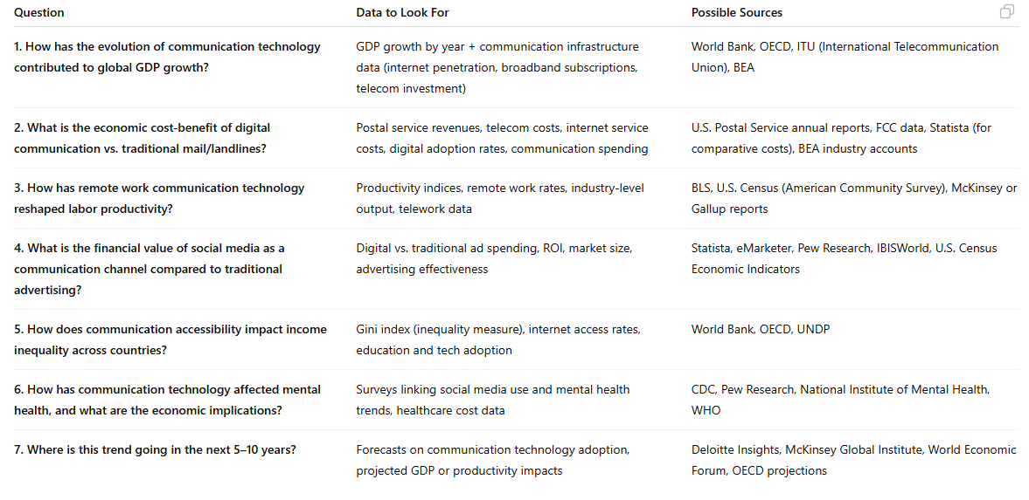
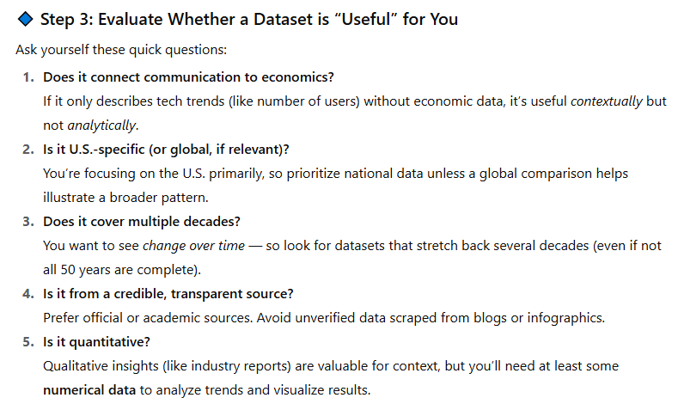
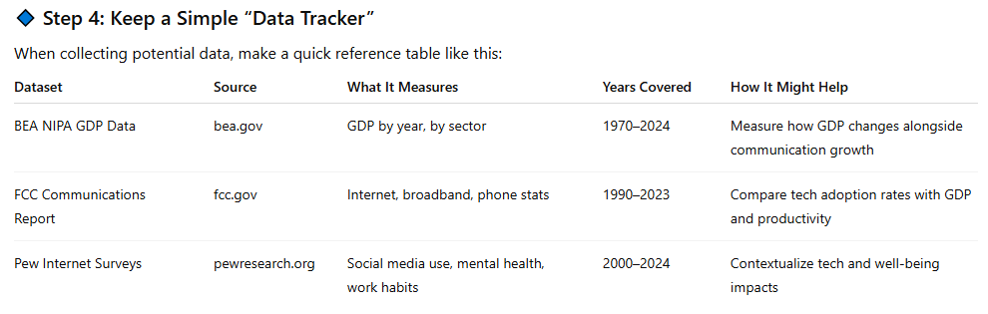
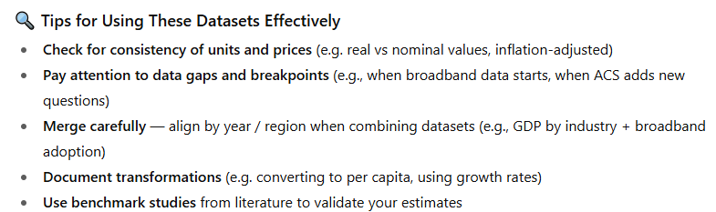
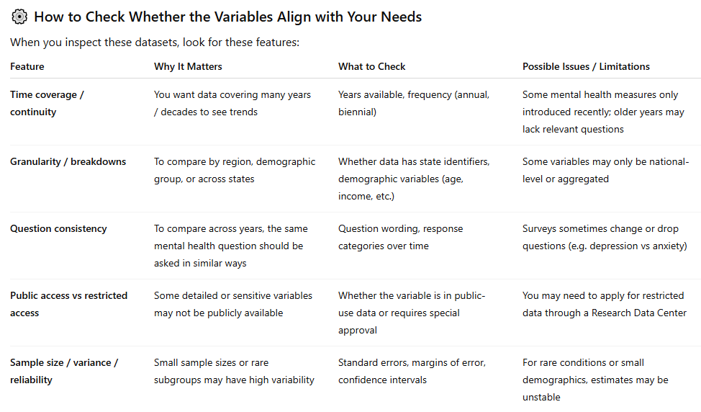

Findings To Know

The nation's gross domestic product totals trillions of dollars. Most often, the number you'll hear people refer to as "GDP" is a percentage. That's the rate of change in real GDP from the previous quarter or year. "Real" or "chained" GDP numbers have been adjusted to remove the effects of inflation over time, so different periods can be compared.
"Current-dollar" or "nominal" GDP estimates are based on market prices during the period being measured.
May not have extremely current data due to:
Due to a partial lapse in federal government funding, the FCC has suspended most operations effective 12:00 a.m. EDT on October 1, 2025. As a result, information on this website may not be up to date. Transactions submitted via this website or other FCC-systems might not be processed altogether or processing time may be delayed until appropriations are enacted. The FCC may not be able to respond to inquiries or response time may be delayed until appropriations are enacted. For more information, refer to: Impact of Potential Lapse in Funding on Commission Operations

